iOS Mobile Applications: First Partial

University name: University La Salle Chihuahua
Student full name: Jorge Parra Hidalgo
Student ID number: 13104
Professor’s name: Jorge Luis Romo

SECTION 1 – macOS Basics
- Mention the last three macOS versions.
The three most recent major macOS versions are macOS Ventura, macOS Sonoma, and macOS Sequoia.

- What is Spotlight and how do you open it?
Use Command + Space to launch Spotlight, the built-in system search tool that locates apps, files, settings, and even do computations.

- What is the macOS Terminal used for?
A command-line interface called the macOS Terminal is used to communicate with the Unix-based system for operations like file management, program execution, system configuration, and development work.

- What is the difference between a .dmg file and a .pkg file?
A.pkg file is an installer package that performs a setup procedure and automatically installs files into system folders, but a.dmg file is a disk image that mounts like a virtual drive and typically requires manually dragging the app to Applications.

- What is Homebrew and why is it useful?
Homebrew is a macOS package manager that improves development and dependency management by enabling you to install, update, and manage software from the command line.

SECTION 2 – Xcode and iOS Environment

What is Xcode?
With tools for coding, interface design, debugging, and testing, Xcode is Apple's official development environment for making programs for iOS, macOS, watchOS, and tvOS.
What is the iOS Simulator used for?
Developers can launch and test iOS apps on a Mac without a physical device thanks to the iOS Simulator.
Does iOS make use of an emulator or a simulator? Describe the distinction.
iOS makes use of a simulator; an emulator replicates the complete hardware architecture of another device, while a simulator executes app code natively on the Mac while mimicking device behavior.

What is an Xcode storyboard?
Using a graphical user interface, developers create app screens and specify navigation between ViewControllers in a Storyboard, a visual layout file.
What is an IBOutlet? Write a short code example.
An IBOutlet is a reference that connects a UI element from the Storyboard to code so it can be accessed and modified programmatically.
@IBOutlet weak var titleLabel: UILabel!

What is an IBAction? Write a short code example.
An IBAction is a method linked to a UI element that executes when the user interacts with it.

How do IBOutlet and IBAction vary from one another?
IBAction links a user interaction event to a function that executes when triggered, whereas IBOutlet links a UI element to code for access and modification.
What is an Xcode asset?
An asset is a resource that is kept in the Assets catalog that is utilized by the app, such as colors, photos, or app icons.
How is an image added to the Assets folder?
Drag the picture file into the catalog after opening Assets.xcassets in Xcode, then give it a name.
How is an image from Assets utilized in your user interface?
In the Storyboard, assign a UIImageView's Image attribute to the asset's name, or use UIImage named with the asset's name to load it in code.

How can a Shake Gesture be replicated in the iOS Simulator?
Choose Shake after selecting Device from the iOS Simulator menu.
Why might an app benefit from a Shake Gesture?
Refreshing content, reporting feedback, reversing input, and enabling secret debug features are just a few of the tasks it can initiate.
How can a class file be linked to a Storyboard ViewController?
Open the Identity Inspector, select the ViewController on the Storyboard, and change the Custom Class to the name of the matching Swift class.

How may a UI element be linked to code?
Launch the Assistant Editor, control-drag the Storyboard UI element to the Swift file, and establish an IBOutlet or IBAction connection.
What are Auto Layout limitations, and what makes them crucial?
In order to ensure that the layout appropriately adjusts to various screen sizes and orientations, auto layout constraints specify the size and position connections between interface elements.

SECTION 3 – Swift Fundamentals
- What is the difference between an inferred variable and an explicit variable? Write one example of each.
An explicit variable includes the type directly in its declaration, but an inferred variable is declared without the type specified since Swift automatically determines the type from the assigned value. Var age = 21 is an example of an inferred variable. Var age: Int = 21 is an example of an explicit variable.

- What is an Optional in Swift?
In Swift, an optional type can either have a value or nil, which indicates that there is no value.

- Why are Optionals important?
Optionals are crucial because they reduce unexpected crashes by making the lack of a value obvious and requiring you to handle nil securely.

- What is force unwrapping and why is it dangerous?
Force unwrapping, which involves using an exclamation point to obtain the value inside an Optional, is risky because if the Optional is nil, the application will crash.

- What is optional binding? Write a small example using if let.
For instance, if let unwrappedName = name { print(unwrappedName) } and var name: String? = "Jorge" are safe ways to unwrap an Optional by first determining whether it has a value.

SECTION 4 – Collections in Swift
- What is an Array?
An Array is an ordered collection of values of the same type that allows duplicates and can be accessed by index.

- What is the main difference between an Array and a Set?
The main difference between an Array and a Set is that an Array maintains order and allows duplicate values, while a Set does not maintain order and only stores unique values.

- What is a Dictionary?
A Dictionary is a collection that stores key–value pairs, where each key is unique and is used to access its associated value.

- Why does accessing a Dictionary value return an Optional?
Accessing a Dictionary value returns an Optional because the key you are searching for might not exist, so Swift must account for the possibility of a missing value.

- When should you use:
a) Use an Array when you need an ordered collection and may have duplicate values.
b) Use a Set when you need to store unique values and do not care about order.
c) Use a Dictionary when you need to associate unique keys with specific values for fast lookup.

SECTION 5 – Practical Exercises
Exercise 1 – Variables
Create:
- One inferred constant called schoolName
- One explicit variable called semester of type Int
- Print both values

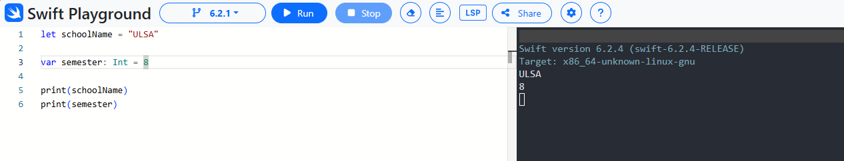

Exercise 2 – Optionals
- Create an optional variable called age
- Assign it a value
- Safely unwrap it using if let
- Print the value
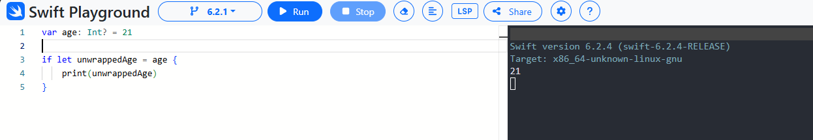

Exercise 3 – Array
- Create an Array of three numbers
- Add a fourth number
- Print the first element
- Print all elements using a loop
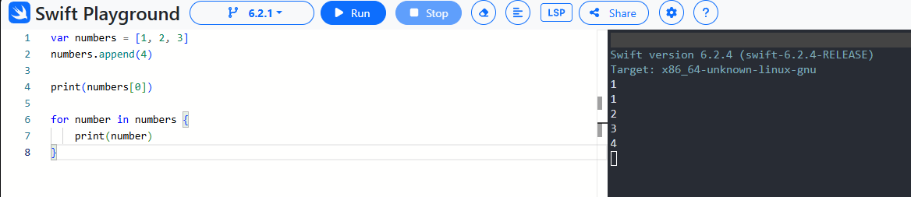

Exercise 4 – Set
- Create a Set with duplicate numbers
- Print the Set
- Explain what happened
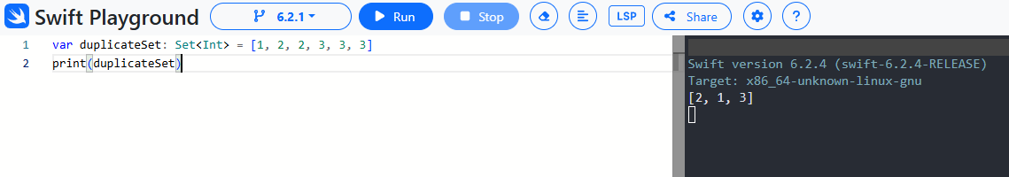

Exercise 5 – Dictionary
- Create a Dictionary with student names and grades
- Add one more student
- Print one specific grade
- Safely unwrap the value before printing
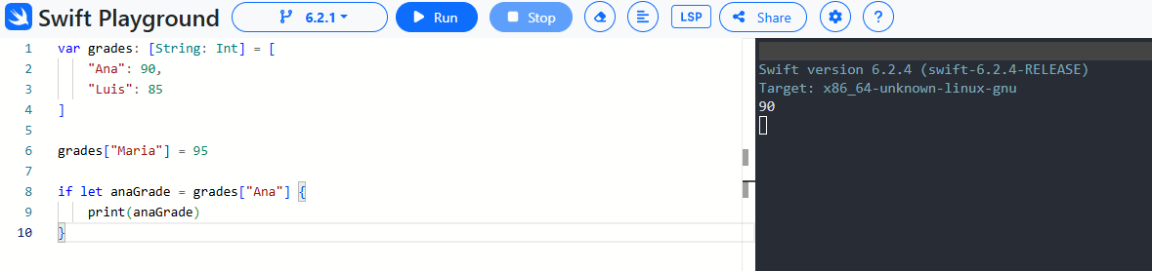

Exercise 6 – Sum of Numbers
Write a program that:
- Creates an Array of five numbers
- Calculates the sum using a loop
- Prints the total
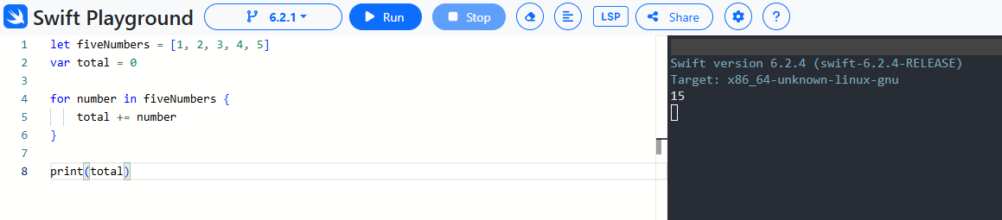

Exercise 7 – Type Safety
- Create an Array of Int
- Try to add a String value
- Explain the error
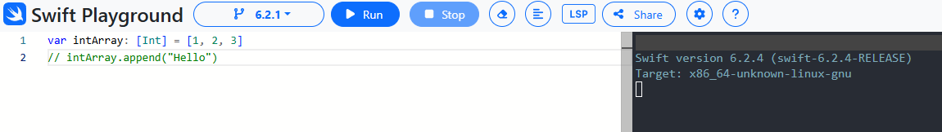

SECTION 6 – Conceptual Thinking
- When should you use a Set instead of an Array?
You should use a Set instead of an Array when you need to store only unique values and do not care about the order of elements.

- What happens if you force unwrap a nil Optional?
If you force unwrap a nil Optional, the application will crash at runtime with a fatal error.

- Why are constraints necessary for different iPhone screen sizes?
Constraints are necessary for different iPhone screen sizes because they define how UI elements resize and reposition, ensuring the layout adapts correctly to various screen dimensions and orientations.

- Why is Swift considered a type-safe language?
Swift is considered a type-safe language because it enforces strict type checking at compile time, preventing you from assigning values of the wrong type and reducing runtime errors.

- Why is IBOutlet declared as weak in most cases?
IBOutlet is declared as weak in most cases to avoid strong reference cycles, since the view hierarchy already holds a strong reference to the UI element.

- What would happen if an IBOutlet is not connected in Storyboard but used in code?
If an IBOutlet is not connected in the Storyboard but is used in code, it will be nil at runtime and will cause a crash if force unwrapped or accessed without proper optional handling.

